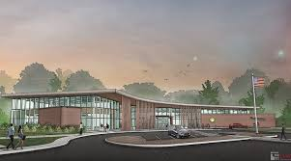

Draft Agenda

Board of Trustees—MidPointe Library System

June 18, 2025

1:00 p.m. Regular Meeting

**NEW - Liberty Branch Library**   
Board Room

1. Call to Order
2. Opening Exercise
3. Roll Call
4. Adoption of Agenda
5. Public Comment
6. Approval of Minutes (Regular Meeting, May 21, 2025)
7. Fiscal Officer
   1. Financial Report, Investments, and Donations
   2. Employee Benefit – Sick Time
8. Executive Director
   1. Executive Director’s Report – May Statistics
   2. State Budget Update
9. Collection Services Director
10. Public Services Director
11. Community Engagement Director
12. Human Resources Director
    1. Employee Handbook Updates
    2. *Executive Session  
       Under the authority of O.R.C. 121-22 (g) (1) To consider the employment of a public employee or official unless the public employee or official requests a public hearing.*
13. Board Comments
    1. REMINDER – No Board Meeting in July
14. Adjournment

Enclosures:

Draft of the May 21, 2025, Meeting Minutes

May 2025 Financial Report

Executive Director’s Report

Public Services Report

HR Report

Employee Handbook Updates