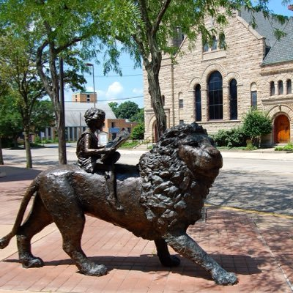

Draft Agenda

Board of Trustees—MidPointe Library System

May 21, 2025

1:00 p.m. Regular Meeting

**Middletown Branch Library**   
Community Room

1. Call to Order
2. Opening Exercise
3. Roll Call
4. Adoption of Agenda
5. Public Comment
6. Approval of Minutes (Regular Meeting, April 16, 2025)
7. Fiscal Officer
   1. Financial Report, Investments, and Donations
   2. 2026 Budget Request
   3. Investment Manager RFP
8. Executive Director
   1. Public Policy Manual Update
9. Development Director
10. Facilities Director
11. Public Services Director
12. Community Engagement Director
13. Human Resources Director
    1. Employee Handbook Updates
14. Board Comments
15. Adjournment

Enclosures:

Draft of the April 16, 2025, Meeting Minutes

April 2025 Financial Report

Budget Request (2)

Executive Director’s Report

Public Policy Manual Update

Public Services Report

Community Engagement Report

HR Report

Employee Handbook Updates