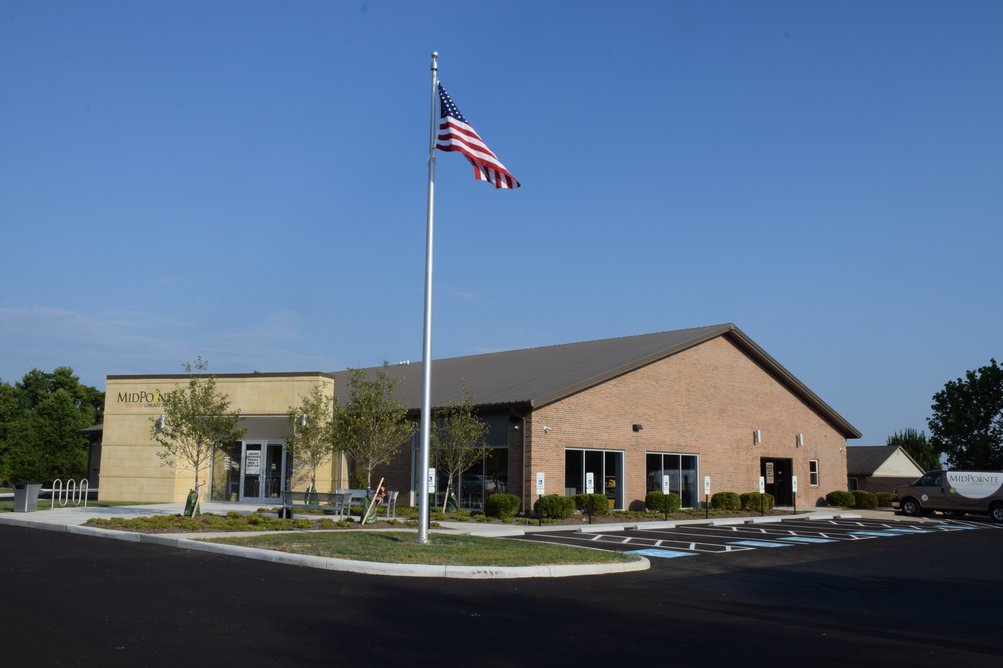
Draft Agenda
Board of Trustees—MidPointe Library System
March 20, 2024
1:00 p.m. Regular Meeting
Trenton Branch

- Call to Order
- Opening Exercise

- Roll Call
- Adoption of Agenda

- Public Comment

- Approval of Minutes
Approve the February 21, 2024, Regular Meeting Minutes
- Fiscal Officer’s Report
  - February 2024 Financial Report, Investments, and Donations
  - Credit Card Policy Update
  - Annual Credit Card Reward Summary 2023
  - Finance Updates
- Director’s Report
  - Liberty/Yankee Road Property Update
  - Public Policy Manual Updates (pending)
- Public Services Report
- Community Engagement Report
- Human Resources Report
  - Staffing and HR Updates

- Board Comments
- Adjournment

Enclosures:
Draft of the February 21, 2024 Meeting Minutes
February 2024 Financial Report
Credit Card Policy Update (DRAFT)
Director’s Report
Public Services Report
Community Engagement Report
Staffing and HR Updates

