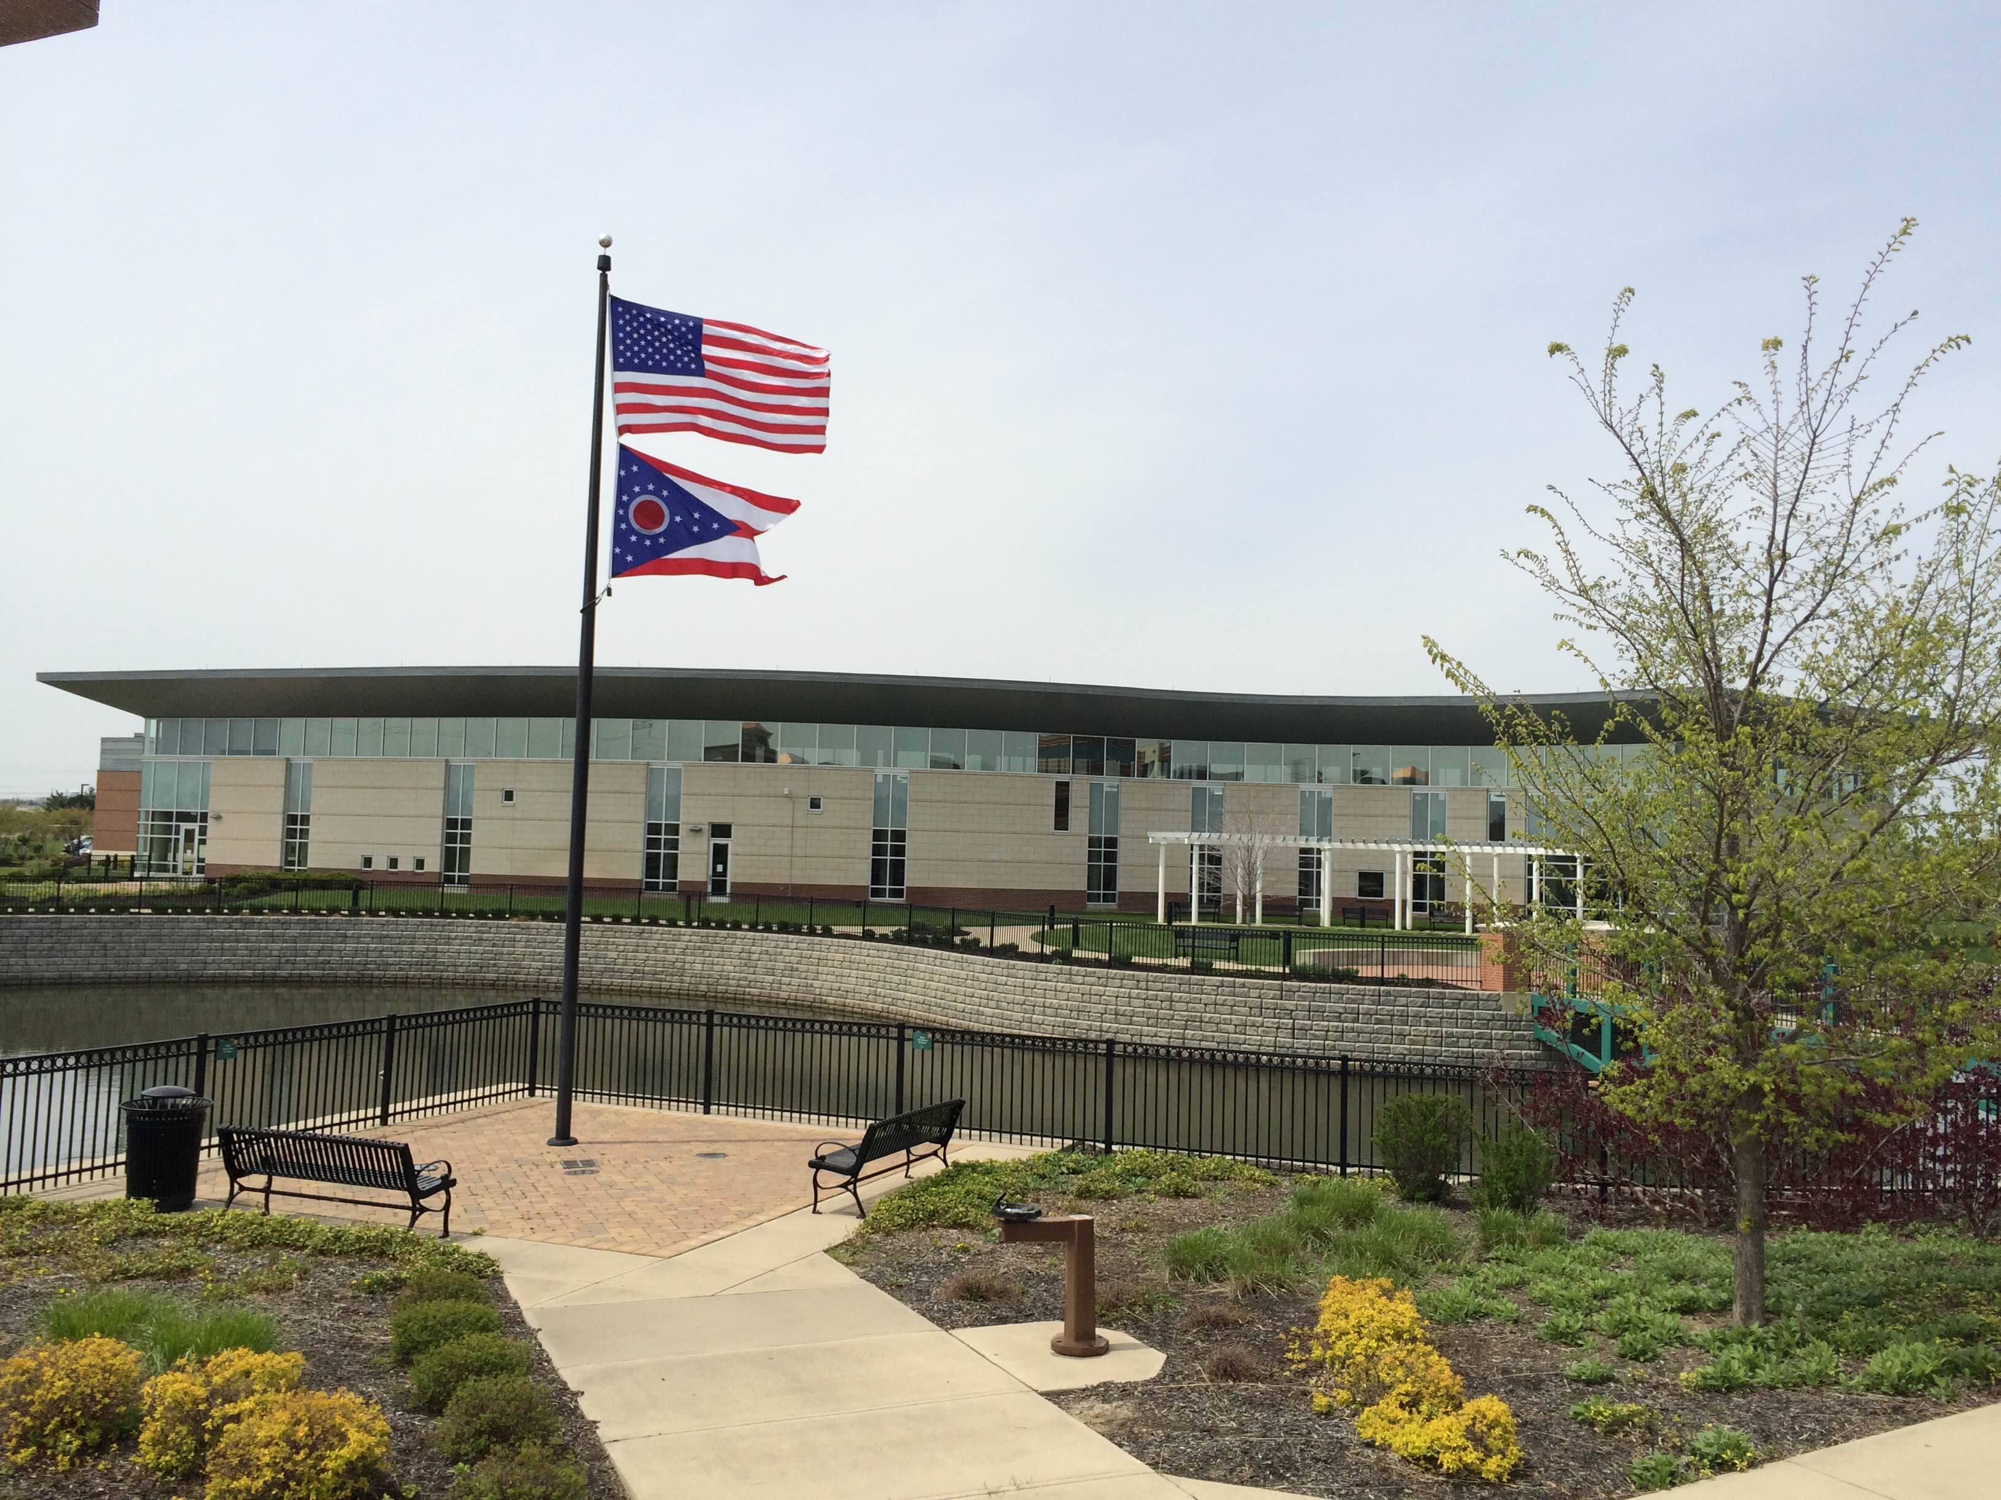

Draft Agenda
Board of Trustees—MidPointe Library System
February 21, 2024
1:00 p.m. Regular Meeting
West Chester Branch

- Call to Order
- Opening Exercise

- Roll Call
- Oaths of Office
- Board Roster / Committee Assignments
- Adoption of Agenda

- Public Comment
- Middletown City Liaison Update

- Approval of Minutes
Approve the January 17, 2024, Organizational Meeting Minutes
- Fiscal Officer’s Report
  - January 2024 Financial Report, Investments, and Donations
  - Year-End Financial Report 2023
  - Audit Update

- Director’s Report
  - Yankee Road Project Updates
  - Credit Card Audit Report

- Public Services Report
- Community Engagement Report
- Human Resources Report
  - Staffing and HR Updates

- Board Comments
- Adjournment
Enclosures:

Draft of the January 17, 2024 Organizational Meeting Minutes
Oath of Office
Board Roster / Committee Assignments
January 2024 Financial Report
Year-End Financial Report 2023
Director’s Report
Credit Card Audit Report
Public Services Report
Community Engagement Report
Staffing and HR Updates

