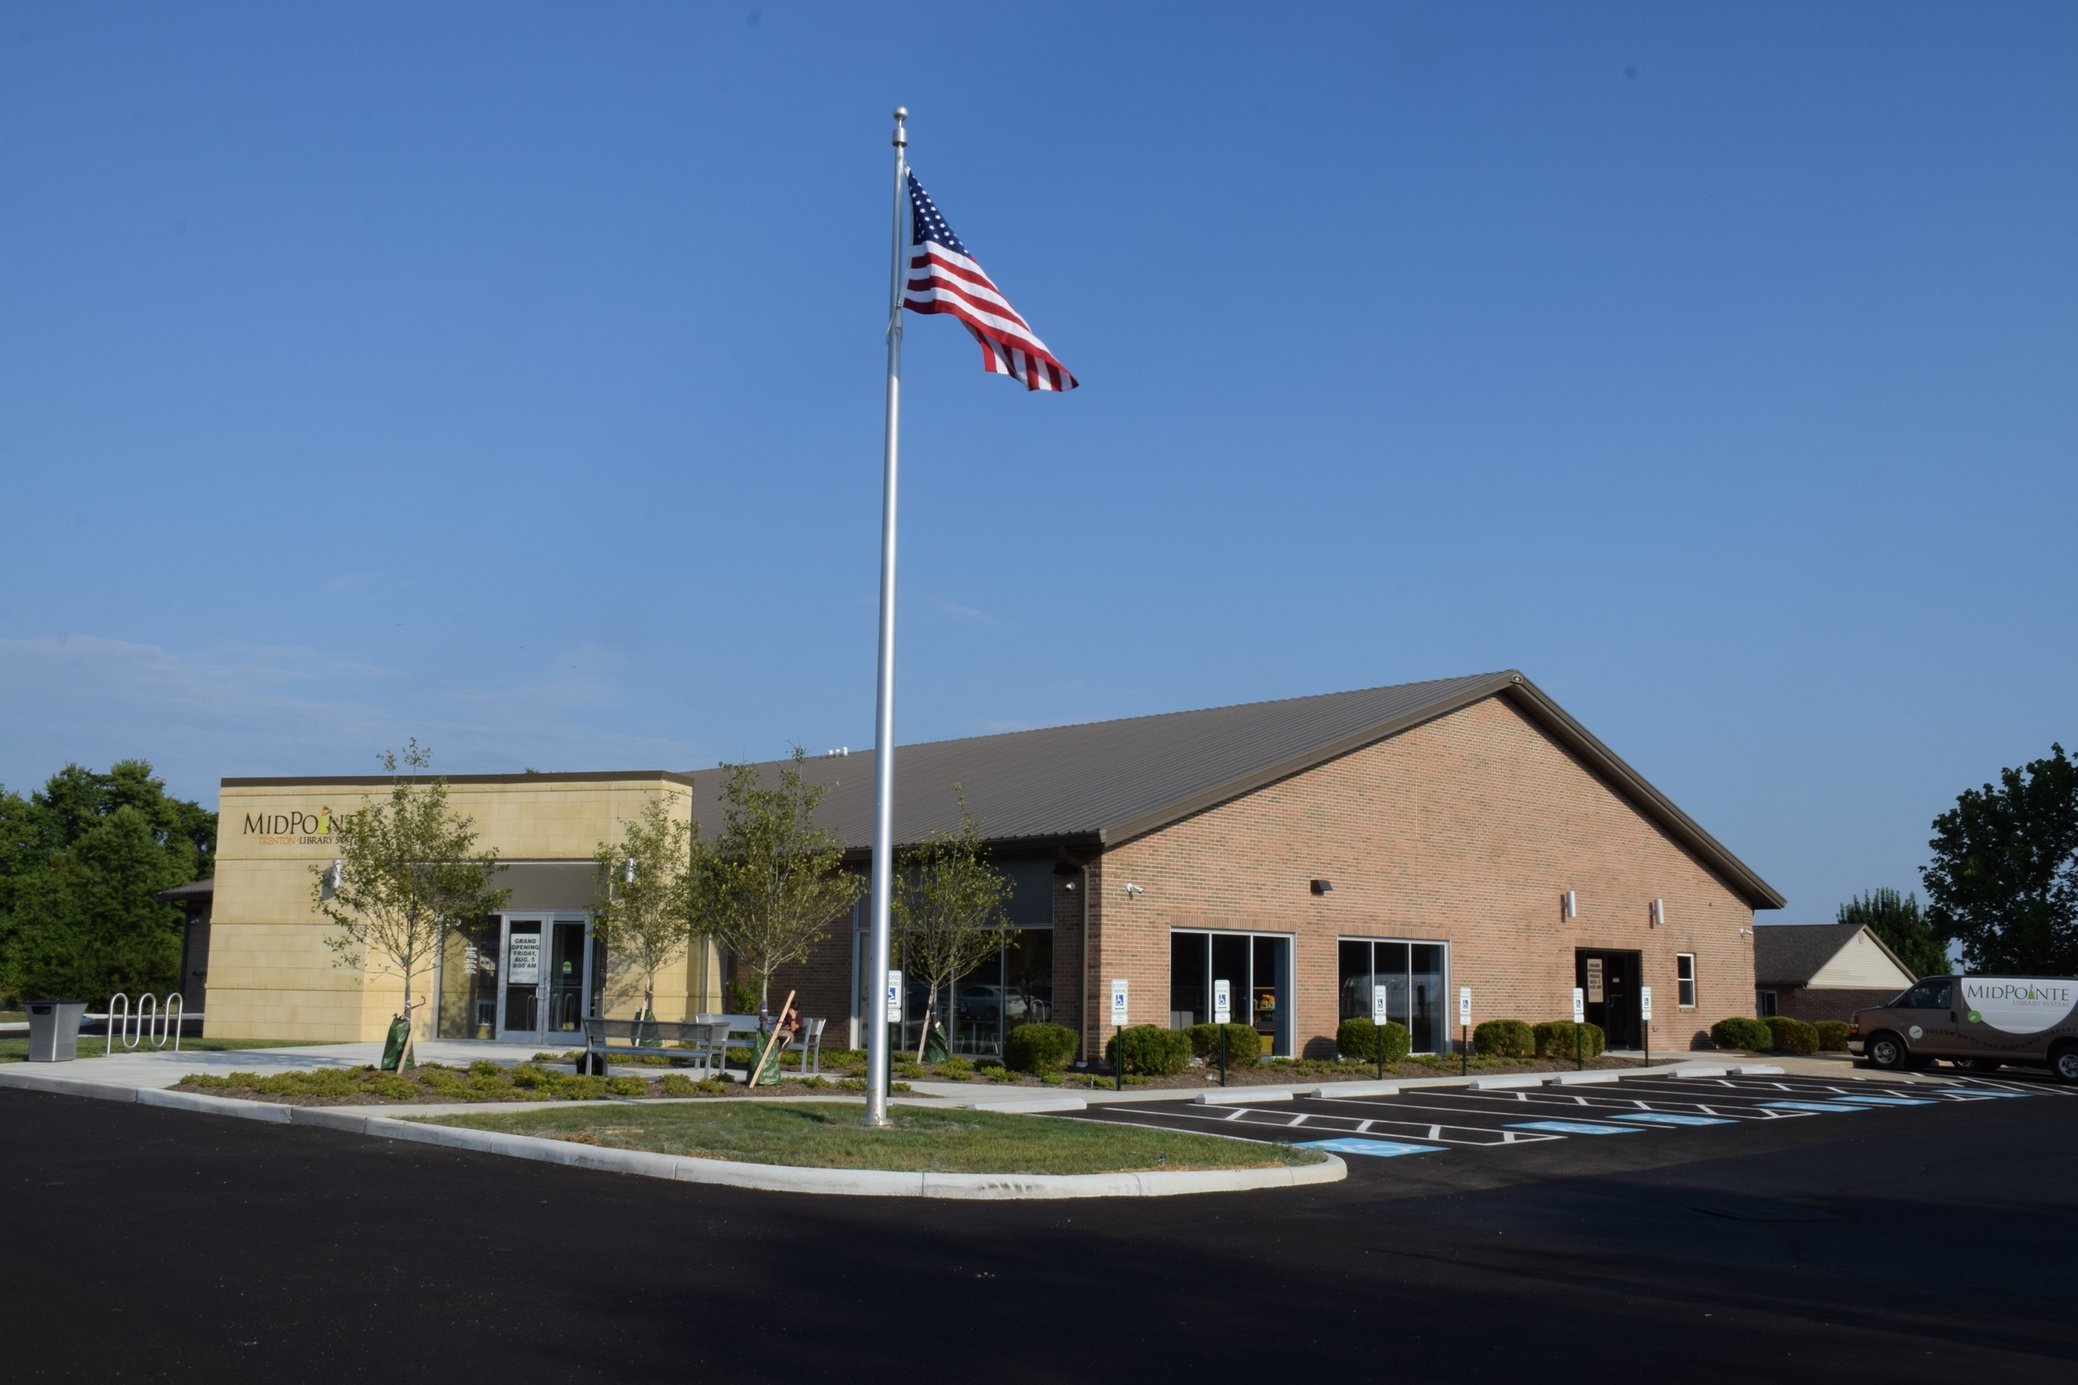
Final Agenda
Board of Trustees—MidPointe Library System
December 13, 2023
1:00 p.m. Regular Meeting
Trenton Branch

- Call to Order
- Opening Exercise

- Roll Call
- Adoption of Agenda

- Public Comment

- Approval of Minutes
Approve the November 15, 2023 Meeting Minutes
- Fiscal Officer’s Report
  - November 2023 Financial Report, Investments, and Donations
  - Resolution - 2024 Annual Appropriation
  - Motion - Transfer Cash from General Fund to Capital Improvement Fund
  - Discussion - Debt Issuance

- Director’s Report
  - Liberty Construction Bid
  - West Chester Updates

- Public Services Report
- Community Engagement Report
- Human Resources Report
  - Staffing and HR Updates
- Board Comments
  - Trustee Recognition
- Adjournment
Enclosures:

Draft of the November 15, 2023 Meeting Minutes
November 2023 Financial Report
Director’s Report
Public Services Report
Community Engagement Report
Staffing and HR Updates

