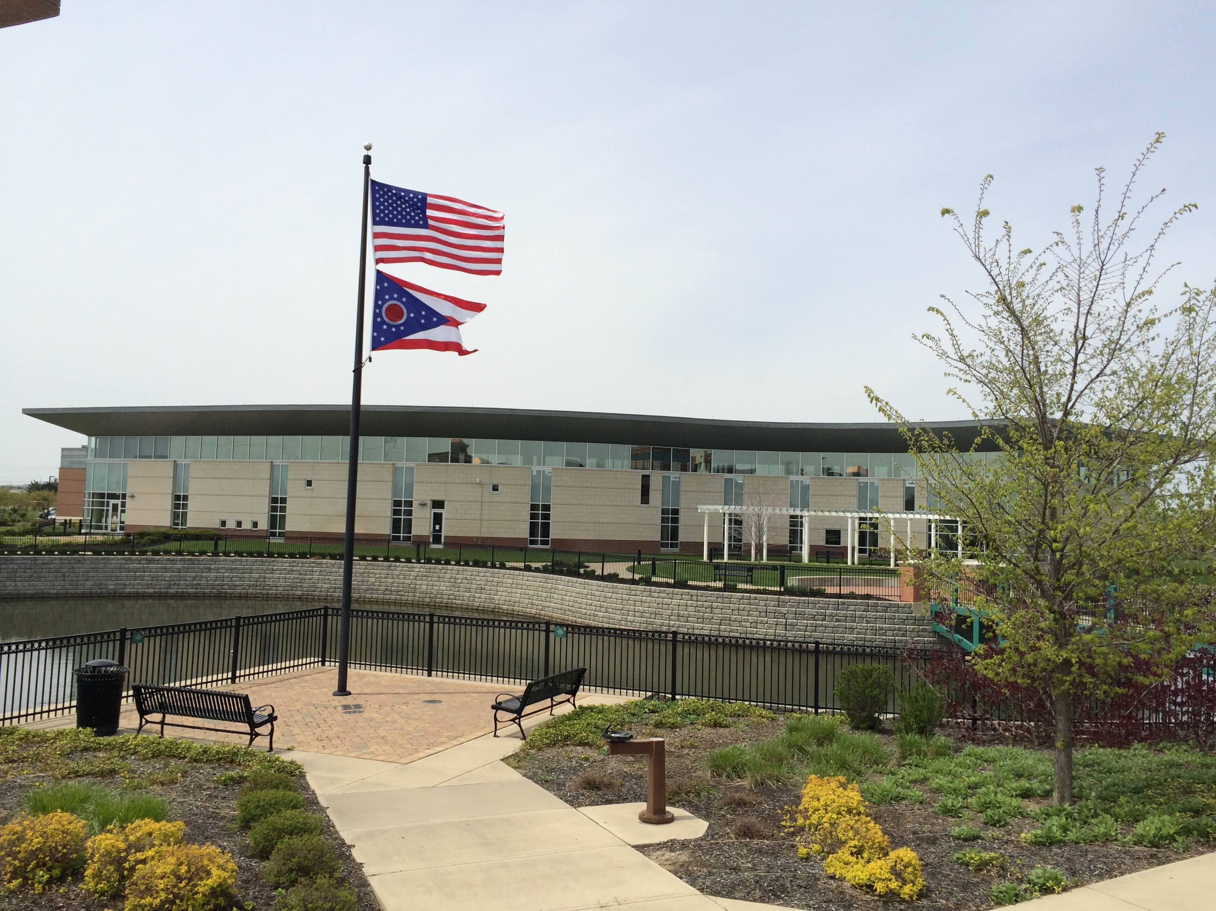

Draft Agenda
Board of Trustees—MidPointe Library System
November 15, 2023
1:00 p.m. Regular Meeting
West Chester Branch

- Call to Order
- Opening Exercise

- Roll Call
- Adoption of Agenda

- Public Comment

- Approval of Minutes
Approve the October 18, 2023, Meeting Minutes
- Fiscal Officer’s Report
  - October 2023 Financial Report, Investments, and Donations
  - Budget 2023 Update

- Director’s Report
  - Innovation Pointe Update
  - Project Updates

- Public Services Report
- Community Engagement Report
- Human Resources Report
  - Staffing and HR Updates
  - HR Subcommittee Report
  - Executive Session
Under the authority of O.R.C. 121-22 (g) (1) To consider the compensation of a public employee or official unless the public employee or official requests a public hearing.
  - Compensation
- Board Comments
- Adjournment

Enclosures:

October 2023 Financial Report
Director’s Report
Public Services Report
Community Engagement Report
Staffing and HR Updates

