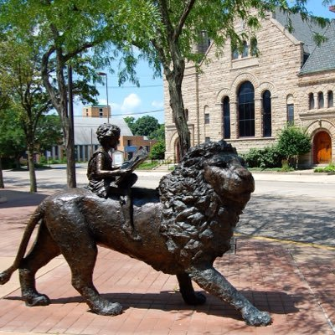

Draft Agenda
Board of Trustees—MidPointe Library System
October 18, 2023
1:00 p.m. Regular Meeting
Middletown Branch Board Room

- Call to Order

- Opening Exercise

- Roll Call
- Adoption of Agenda

- Public Comment

- Approval of Minutes (Regular Meeting, September 20, 2023)
- Fiscal Officer’s Report
  - Financial Report, Investments, and Donations
  - Resolution for Butler County Budget Commission

- Director’s Report
  - Liberty / Yankee Road Project Update
  - Staff Day Presentation

- Public Services Report
  - Tasha Marcum, Sunrise Treatment Center
- Community Engagement Report
- Human Resources Report
  - Staff Day Update
- Board Comments
- Adjournment
Enclosures:
Financial Report for September 2023
Butler County Resolution
Draft of the September 20, 2023, Meeting Minutes
Director’s Report
Staff Day Presentation
Public Services Report
Community Engagement Report
HR Report

