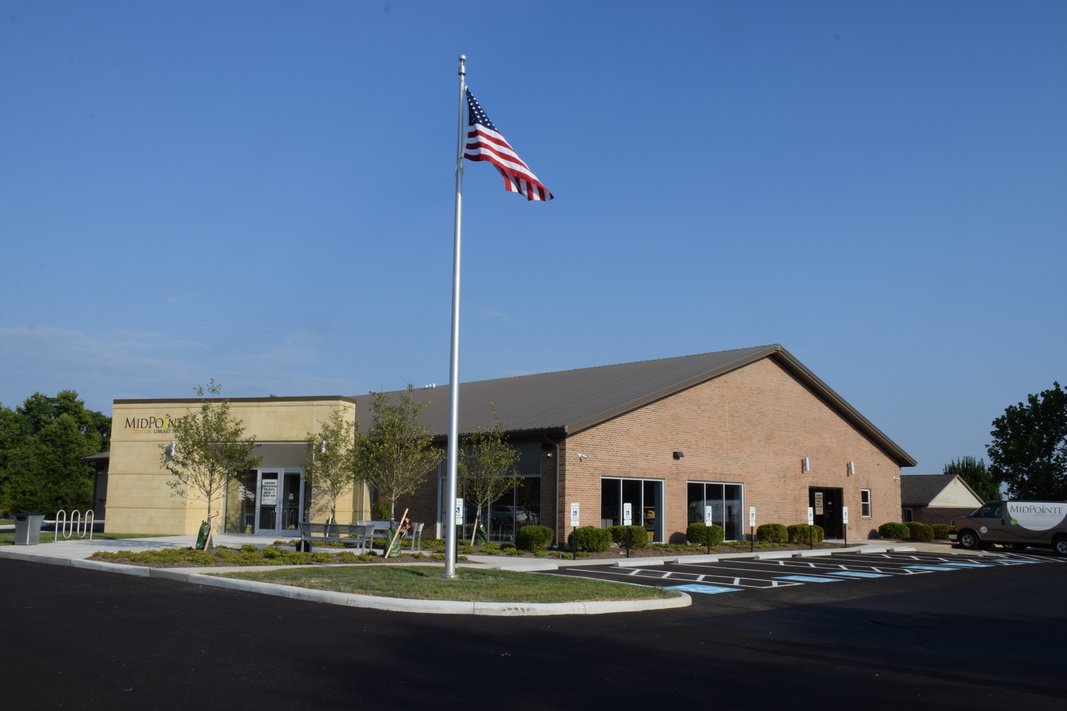
Draft Agenda
Board of Trustees—MidPointe Library System
August 16, 2023
1:00 p.m. Regular Meeting
Trenton Branch

- Call to Order
- Opening Exercise

- Roll Call
- Adoption of Agenda

- Public Comment
- July Roll Call (correction)

- Approval of Minutes
Approve the July 19, 2023, Regular Meeting Minutes
- Fiscal Officer’s Report
  - July 2023 Financial Report, Investments, and Donations
- Director’s Report
  - Liberty/Yankee Road Property Update
  - Operational Updates
- Public Services Report
- Community Engagement Report
- Human Resources Report
  - Staffing and HR Updates
  - Employee Handbook Update

- Board Comments
- Adjournment

Enclosures:
Draft of the July 19, 2023 Meeting Minutes
July 2023 Financial Report
Director’s Report
Public Services Report
Community Engagement Report
Staffing and HR Updates
Employee Handbook Update

