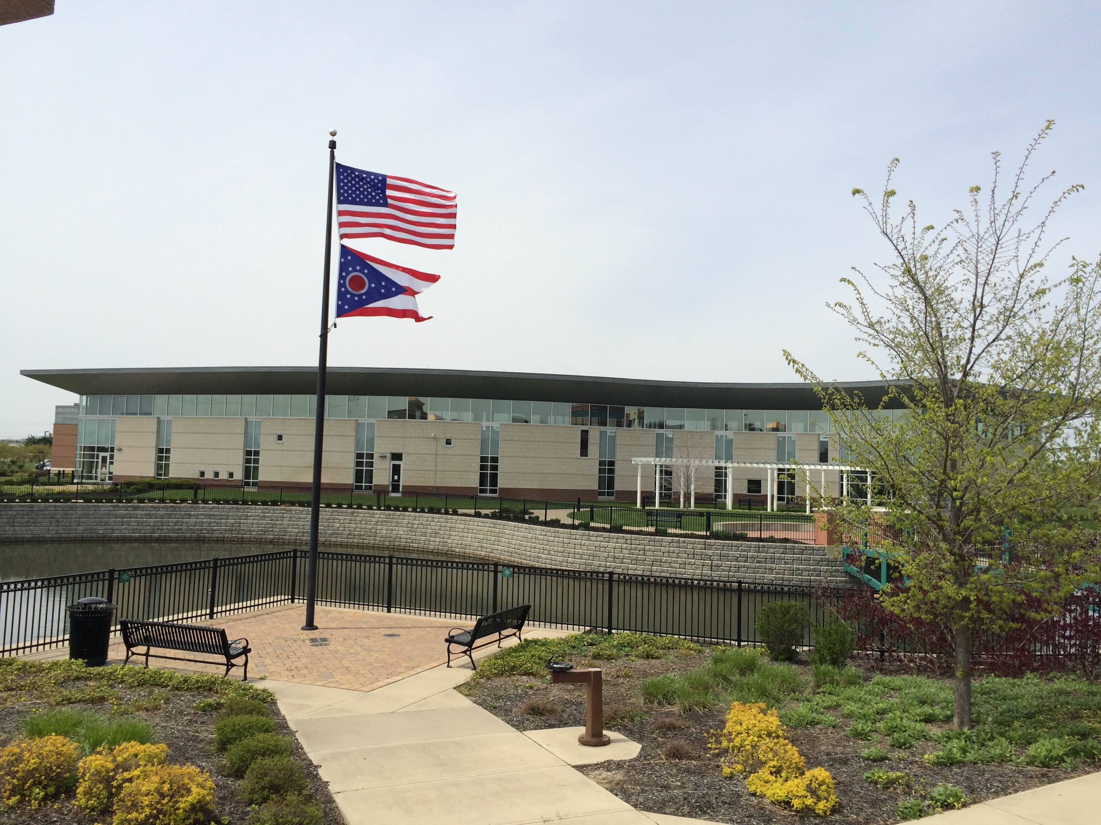

Draft Agenda
Board of Trustees—MidPointe Library System
July 19, 2023
1:00 p.m. Regular Meeting
West Chester Branch

- Call to Order
- Opening Exercise

- Roll Call
- Adoption of Agenda

- Public Comment

- Approval of Minutes (2)
Approve the May 17, 2023 Regular Meeting Minutes
Approve the June 2, 2023 Special Meeting Minutes
- Fiscal Officer’s Report (2)
  - Financial Report, Investments, and Donations for May and June 2023
  - Bank RFP
  - Cash Reserve Evaluation

- Director’s Report
  - Yankee Road / Liberty Project Updates
  - Special Collections / New Services Project

- Public Services Report
- Community Engagement Report
- Human Resources Report (2)
  - Staffing and HR Updates for May and June

- Board Comments
- Adjournment

Enclosures:

Draft of the May 17, 2023 Regular Meeting Minutes
Draft of the June 2, 2023 Special Meeting Minutes
May 2023 Financial Report
June 2023 Financial Report
Bank RFP
Cash Reserve Evaluation Document
Director’s Report (July 2023)
Special Collections Report
Public Services Director’s Report
Community Engagement Report
May 2023 Staffing Report
June 2023 Staffing Report

