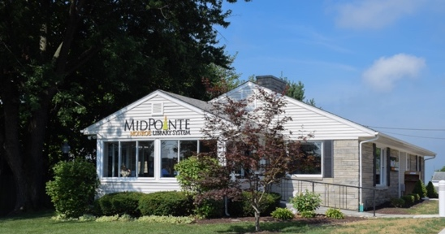
Draft Agenda
Board of Trustees—MidPointe Library System
April 19, 2023
1:00 p.m. Regular Meeting
Monroe Branch – Rothwell Room

- Call to Order

- Opening Exercise

- Roll Call
- Adoption of Agenda

- Public Comment

- Approval of Minutes (Regular Meeting, March 15, 2023)
- Fiscal Officer’s Report
  - Financial Report, Investments, and Donations
  - Deputy Fiscal Officer
- Yankee Road / Liberty Project

- Director’s Report
  - Public Policy Manual Update
  - Staff Survey Results
  - eRate State Contract

- Public Services Report
- Community Engagement Report
- Human Resources Report
  - Staffing Update
  - Employee Handbook Updates
- Board Comments
- Adjournment
Enclosures:
Draft of the March 15, 2023, Meeting Minutes
March 2023 Financial Report
Director’s Report
Draft of Public Policy Manual Update
Staff Survey Results
eRate Contract
Public Services Report
Community Engagement Report
HR Report
Employee Handbook Updates

