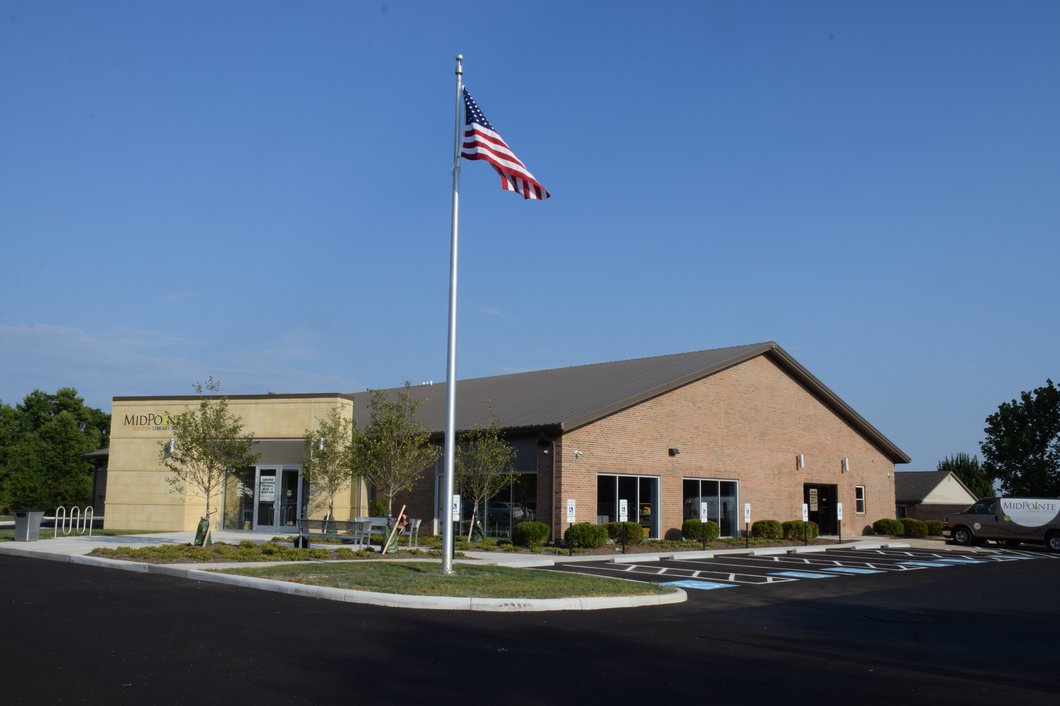

Draft Agenda
Board of Trustees—MidPointe Library System
March 16, 2022
1:00 p.m. Regular Meeting
Trenton Branch

- Call to Order
- Opening Exercise

- Roll Call
- Oath of Office – Deborah Houser
- Adoption of Agenda

- Public Comment
  - Middletown City Liaison Update

- Approval of Minutes
Approve the February 16, 2022, Meeting Minutes
- Facilities Subcommittee Report
- Fiscal Officer’s Report
  - February 2022 Financial Report, Investments, and Donations

- Director’s Report
  - Liberty/Yankee Road Property Update
- Public Services Report
- Community Engagement Report
- Human Resources Report
  - Staffing and HR Updates

- Board Comments
- Adjournment

Enclosures:

Draft of the February 16, 2022 Meeting Minutes
February 2022 Financial Report
Director’s Report
Liberty/Yankee Road Property Update
Public Services Report
Community Engagement Report
Staffing and HR Updates

