Draft Agenda
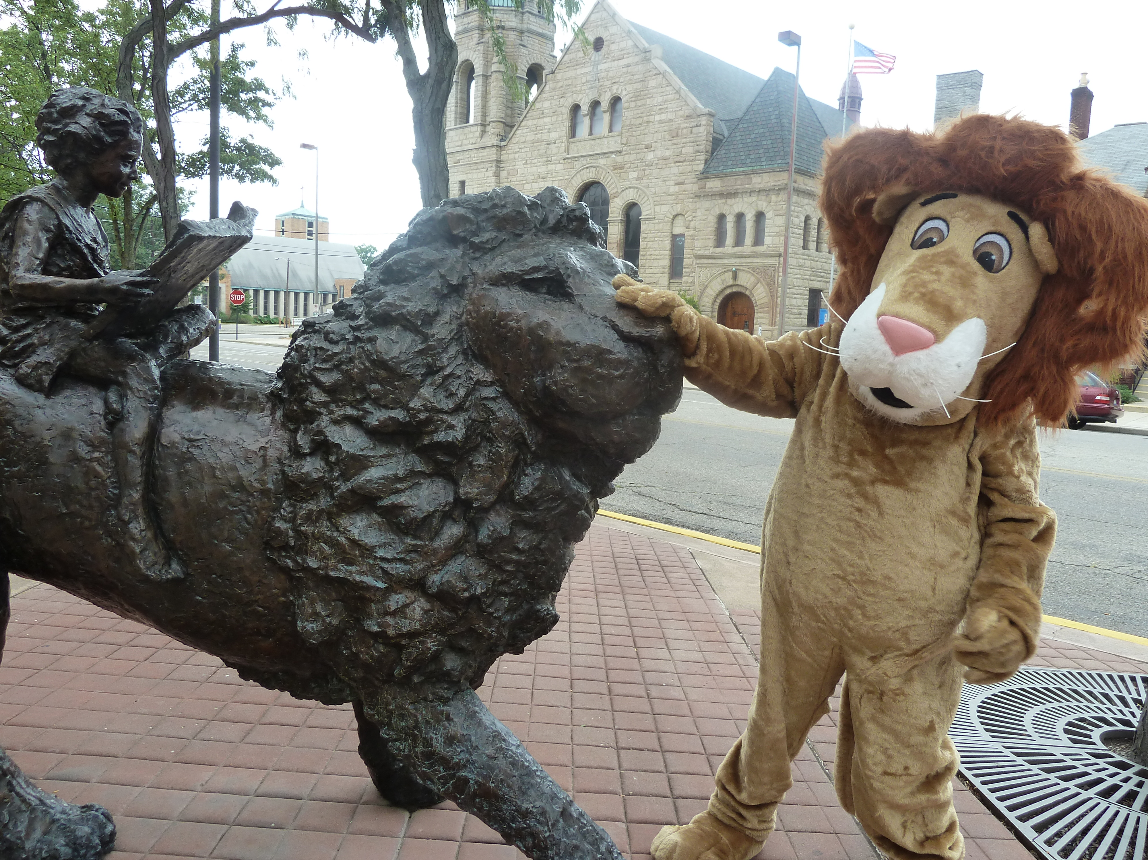
Board of Trustees—MidPointe Library System
July 20, 2021
4:00 p.m. Regular Meeting
Middletown Branch – Board Room

- Call to Order
- Opening Exercise

- Roll Call
- Adoption of Agenda

- Public Comment

- Approval of Minutes
Approve the June 15, 2021 Meeting Minutes
- Fiscal Officer’s Report
  - June 2021 Financial Report, Investments, and Donations

- Director’s Report
  - Project Updates
  - Policy Manual Updates
    - Fine Free
    - Hours of Operation
  - Board Calendar (updated)

- Public Services Report
- Community Engagement Report
- Human Resources Report
  - Staffing and HR Updates
  - Staff Guest – Martha Griffin, Staff Training & Development Coordinator
- Board Comments
- Adjournment

Enclosures:

Draft of the June 15, 2021 Meeting Minutes
June 2021 Financial Report
Director’s Report
Public Policy Manual Updates
Public Services Report
Community Engagement Report
Staffing and HR Updates
Board Calendar (updated)

