Agenda
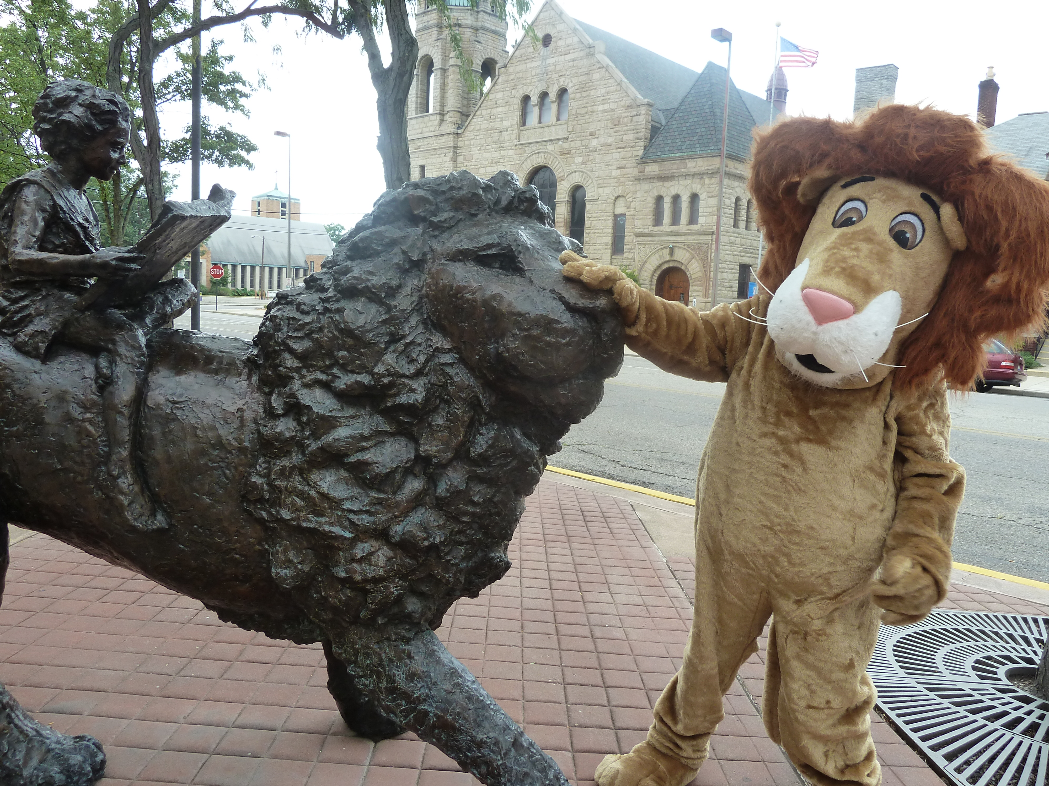
Board of Trustees—MidPointe Library System
January 19, 2021
4:10 p.m. Organizational Meeting
Middletown Branch – Board Room

- Call to Order by President Pro Tem

- Opening Exercise

- Roll Call

- 2021 Board
  - Oath of Office, New Trustee
    - Eleanor Stewart
  - Oath of Office, Election of Officers
The President Pro Tem will conduct the election of board officers.
  - Board Meeting Calendar (draft)
  - Board Committees (draft)
- Adoption of Agenda

- Public Comment

- Approval of Minutes (December 15, 2020)
- Fiscal Office
  - Hiring of the Fiscal Officer
  - Oath of Office, Fiscal Officer
  - Oath of Office, Deputy Fiscal Officer
- Fiscal Officer’s Report
  - Financial Report, Investments, and Donations
  - Resolution for the Appreciation and Acknowledgment of Staff, Volunteers, and Citizens

- Director’s Report
  - Annual Statistical Report
  - Credit Card Compliance Audit

- Public Services Report
- Community Engagement Report

(page 2)
- Human Resources
  - Staffing Updates
  - Policy Updates

- Board Comments
- Adjournment

Enclosures:

Draft of 2021 Board Calendar
Draft of 2021 Board Committee Rosters
January 2021 Meeting Agenda
Draft of the December 15, 2020 Meeting Minutes
December 2020 Financial Report
Director’s Report
Credit Card Audit
Public Services Report
Community Engagement Report
Policy Update

