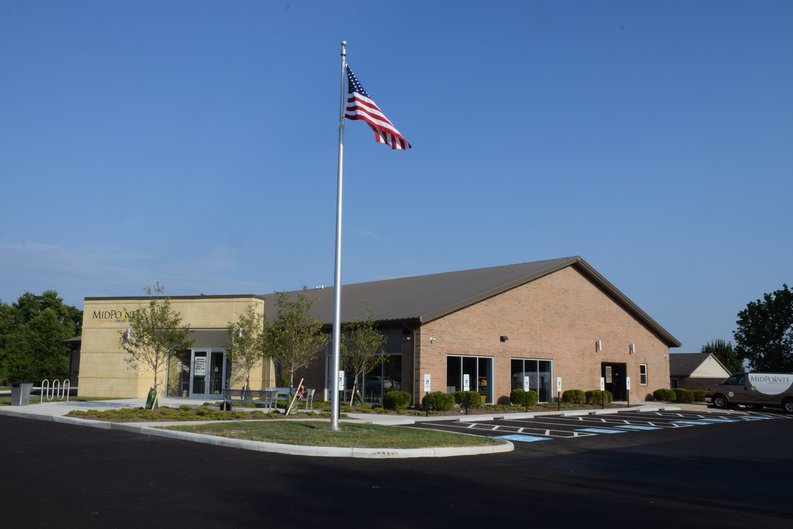
Agenda
Board of Trustees—MidPointe Library System
December 14, 2021
4:00 p.m. Regular Meeting
Trenton Branch

- Call to Order
- Opening Exercise

- Roll Call
- Adoption of Agenda

- Public Comment

- Approval of Minutes
Approve the November 16, 2021 Meeting Minutes
- Fiscal Officer’s Report
  - November 2021 Financial Report, Investments, and Donations

- Director’s Report
  - West Chester Update
  - Liberty Update

- Public Services Report
- Community Engagement Report
- Human Resources Report
  - Staffing and HR Updates
  - Employee Handbook Updates
  - HR Subcommittee Report
  - Executive Session
Under the authority of O.R.C. 121-22 (g) (1) To consider the compensation of a public employee or official, unless the public employee or official requests a public hearing.
  - Compensation
- Board Comments
  - Trustee Recruitment
  - Trustee Recognition
- Adjournment
Enclosures:

Draft of the November 16, 2021 Meeting Minutes
November 2021 Financial Report
Director’s Report
Public Services Report
Community Engagement Report
Staffing and HR Updates
Employee Handbook Updates (draft)

